**PROJECT – REPORT**

**The Tableau HR scorecard: Measuring Success In Talent Management**



**TEAM ID – NM2023TMID06515**

**TEAM MEMBERS:**

**TARUN K (asunm1319222104957)**

**SURENDAR J (asunm1319222104911)**

**SUBASH P (asunm1319222104955)**

**SRIDHAR E (asunm1319222104953)**

**1.INTRODUCTION:**

**1.1 OVERVIEW**

The Tableau HR scorecard is a powerful and interactive data visualization tool designed to measure and track success in talent management within organizations. Leveraging Tableau's robust data analytics and visualization capabilities, this scorecard provides a dynamic and visually engaging way to assess various aspects of HR and talent management. It enables HR professionals and decision-makers to gather, analyze and present data on key performance indicators related to recruitment, employee development, retention, and overall HR effectiveness.

By using Tableau HR scorecard, organizations can transform raw HR data into meaningful insights and actionable information. This data-driven approach facilitates a deeper understanding of talent management processes and their impact on the organization, allowing for evidence-based decision-making. Ultimately, the Tableau HR scorecard plays a pivotal role in helping companies enhance their HR strategies, optimize their talent resources, and achieve success in talent management.

**1.2 PURPOSE**

Tableau HR Scorecard is a tool that helps organizations measure and analyze various metrics related to talent management, particularly in the HR (Human Resources) domain. The purpose of a Tableau HR Scorecard for measuring success in talent management

**2. PROBLEM DEFINITION & DESIGN THINKING**

**2.1 EMPATHY MAP**

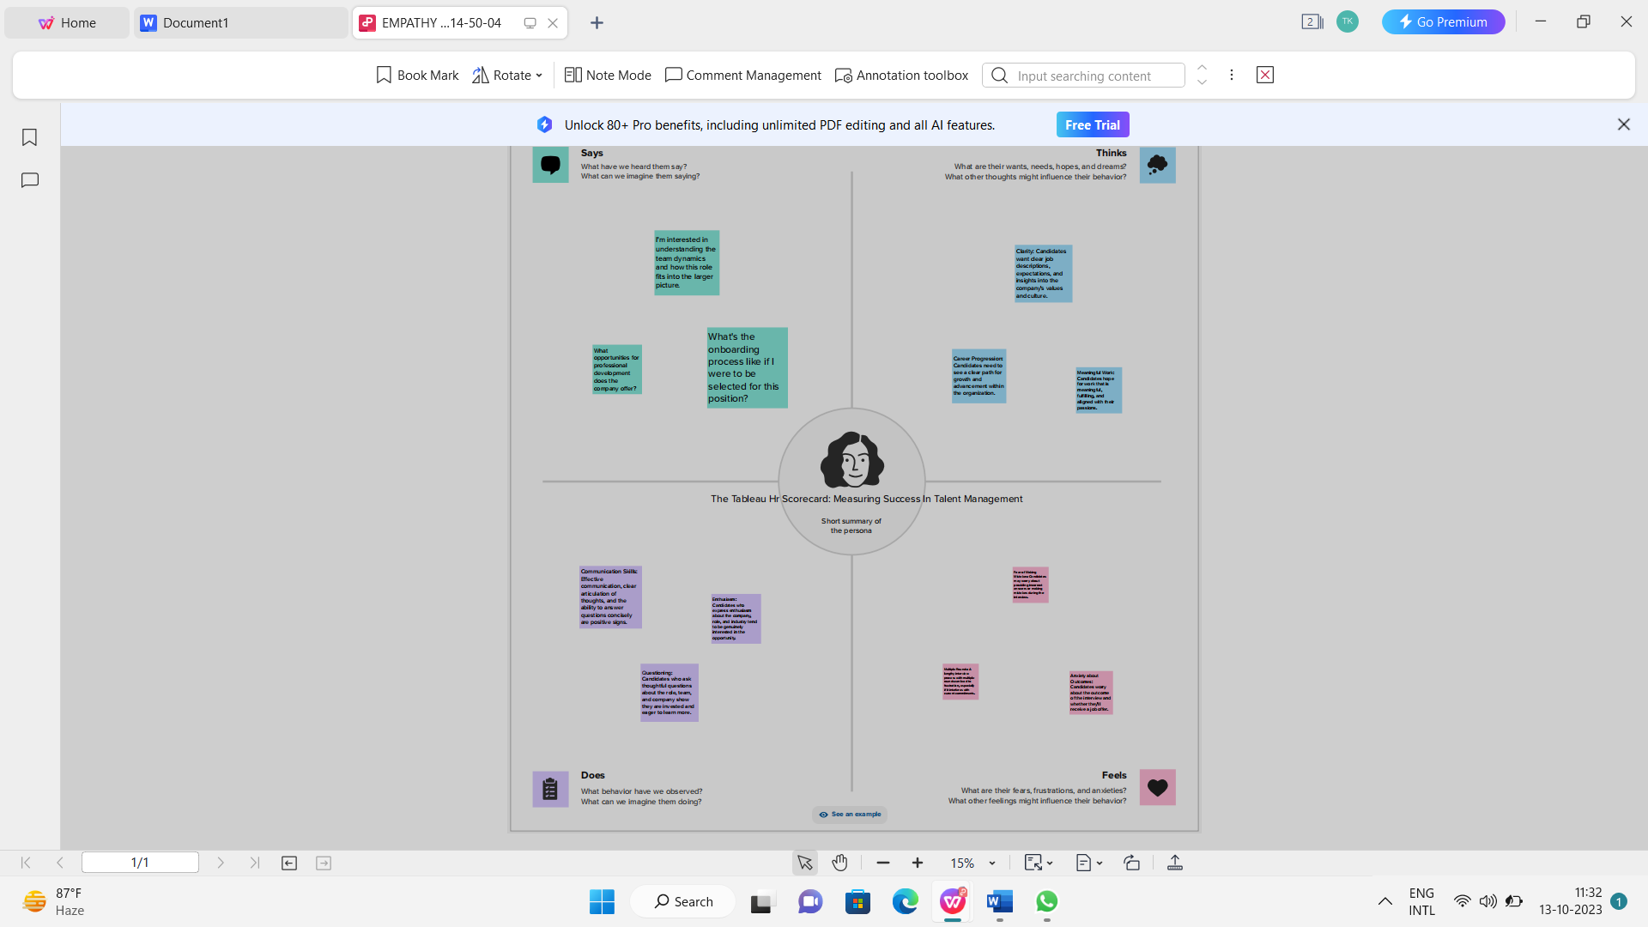

**2.2 IDEATION & BRAINSTROMING MAP**

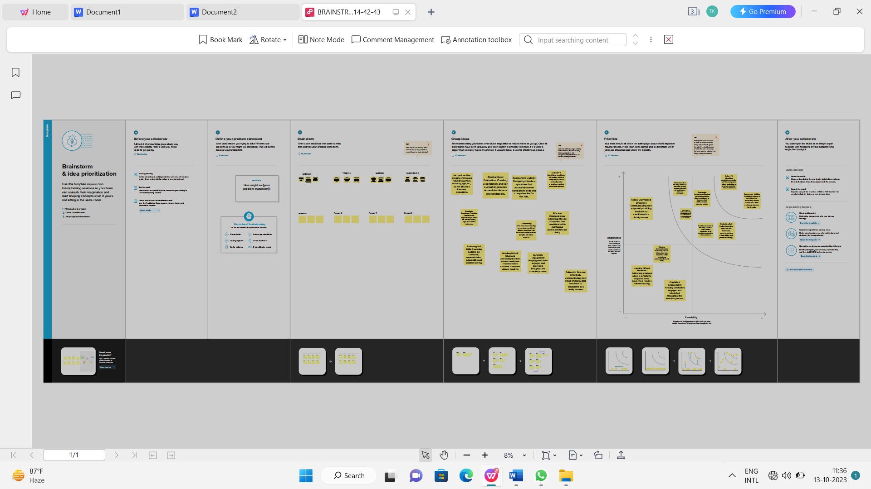

**3. RESULT:**

**1.DEPARTMENT WISE ATTRITION**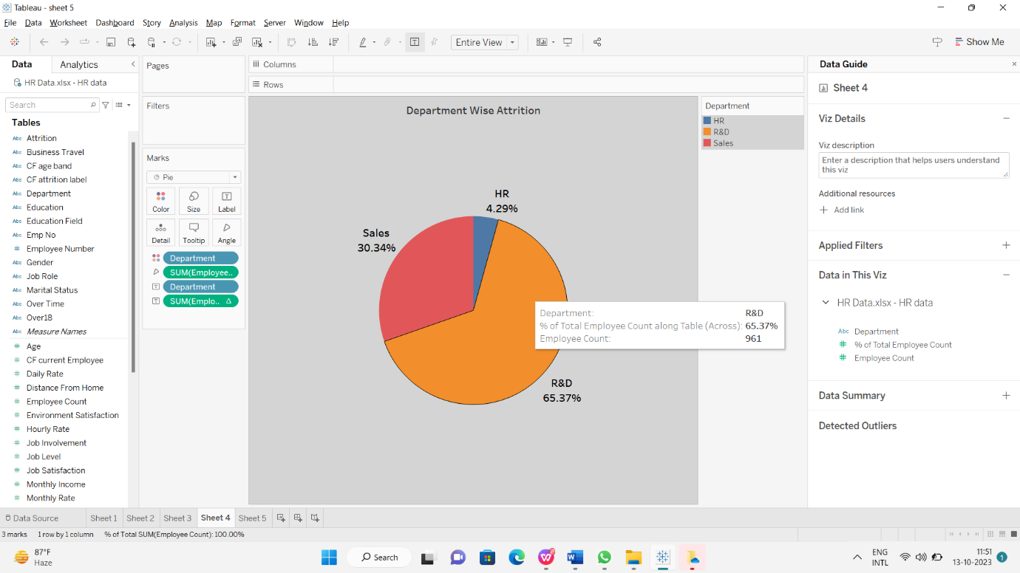

**2. NO. OF EMPLOYEES BY AGE GROUP**

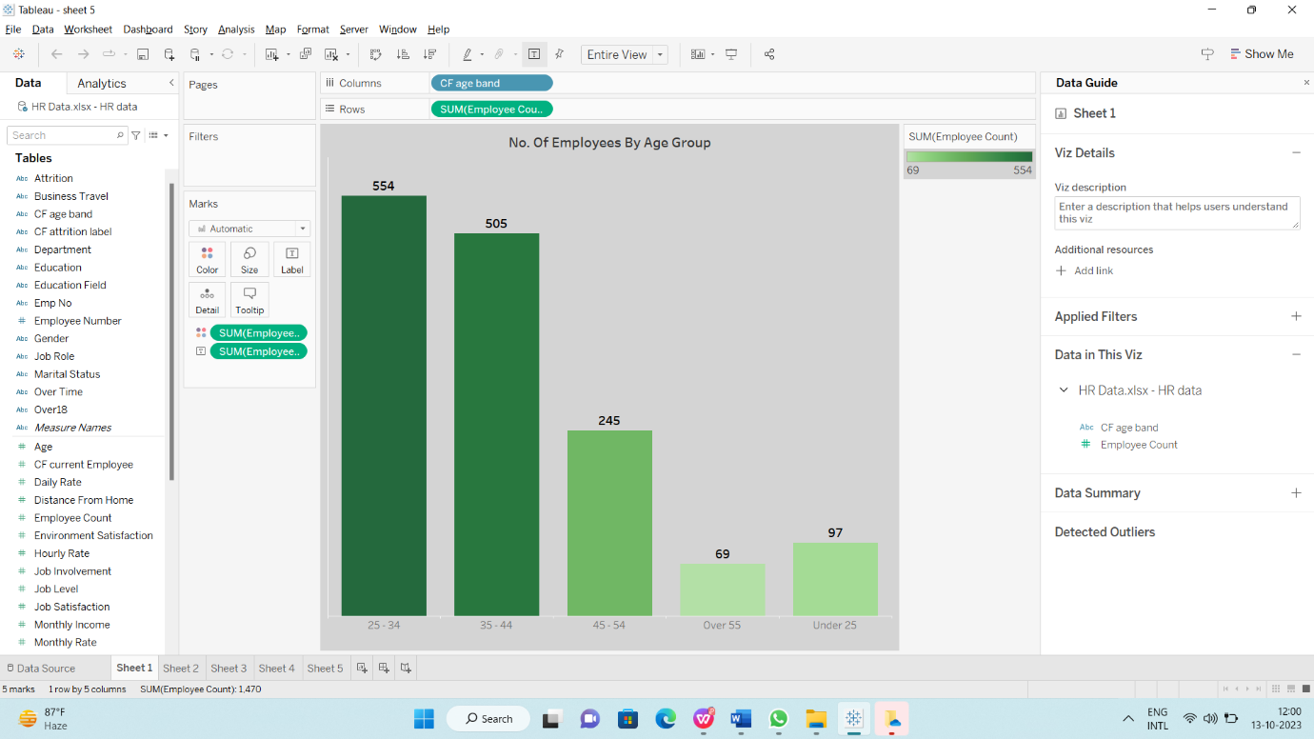

**3. JOB SATISFACTION RATING**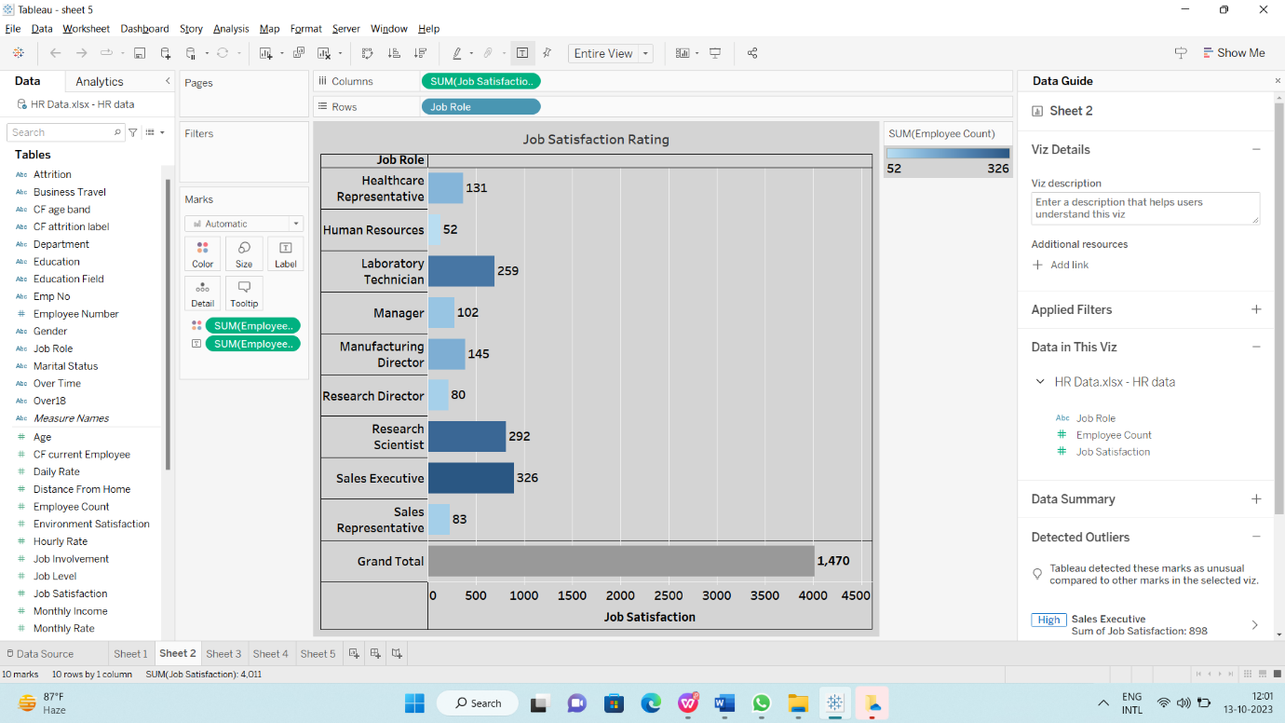

**4. EDUCATION FIELD WISE ATTRITION**

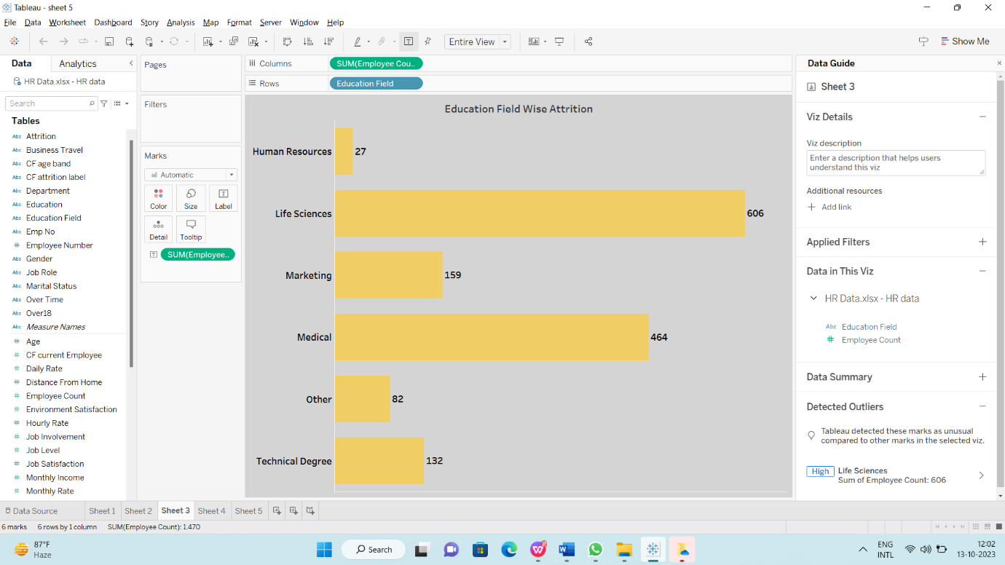

**5. MONTHLY INCOME WISE ATTRITION**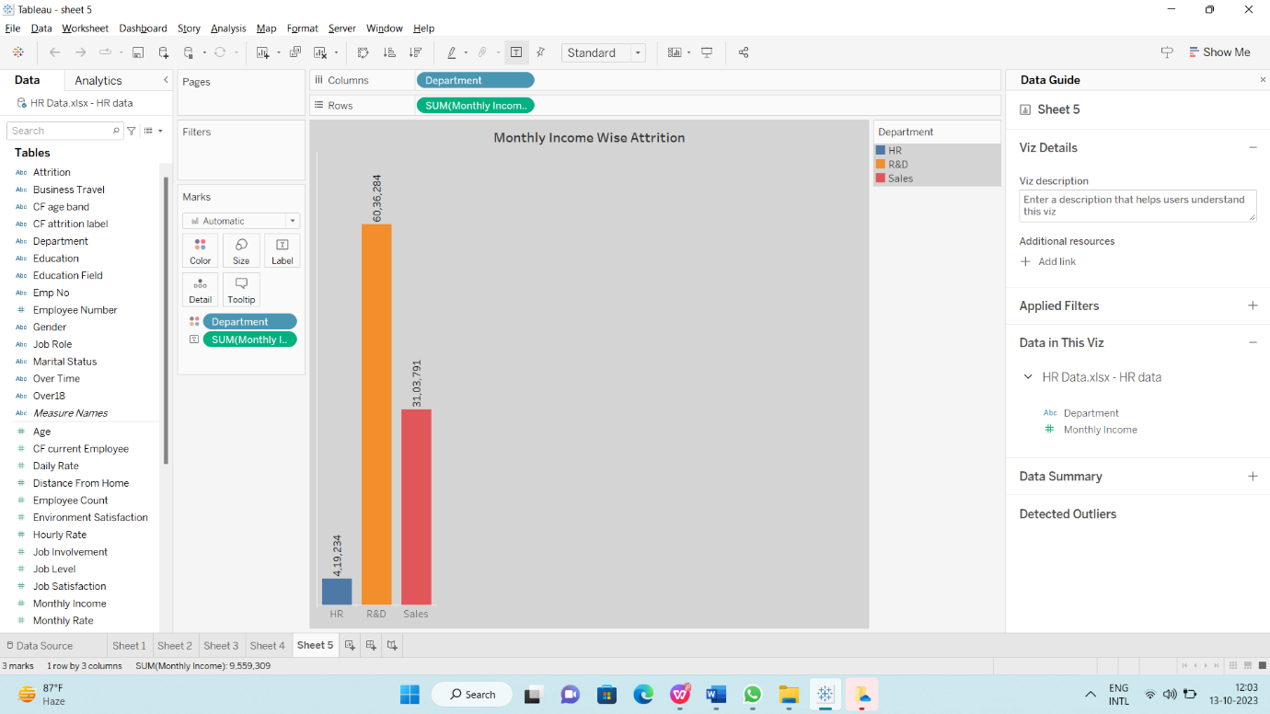

**DASHBOARD:**

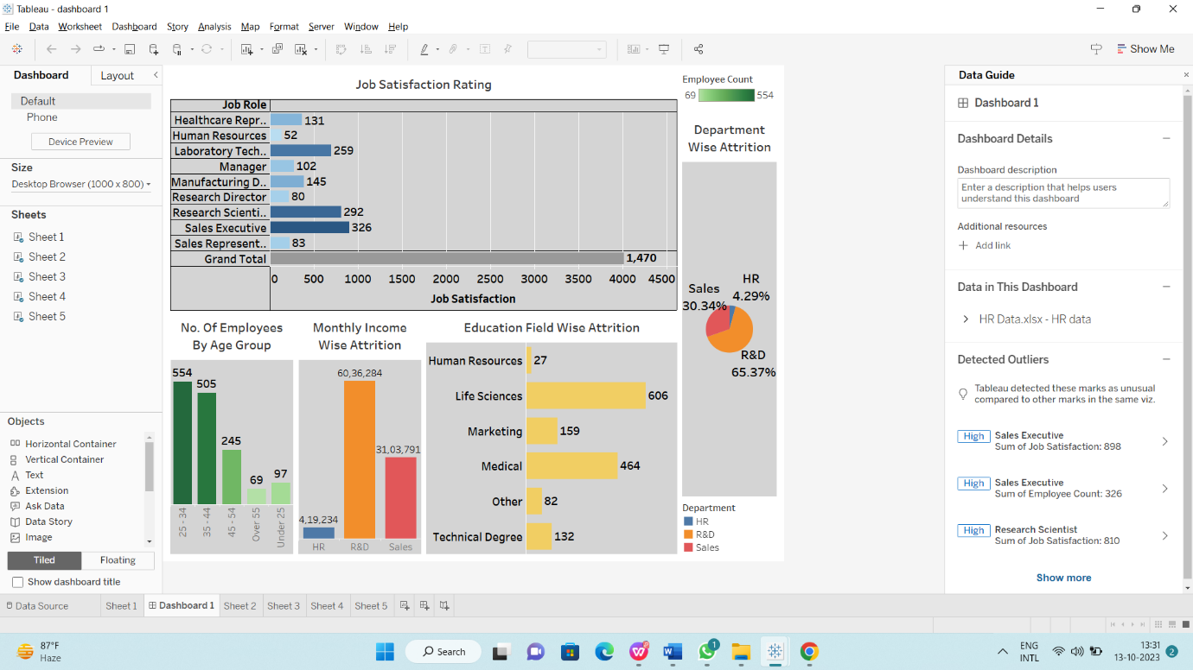

**STORYLINE:**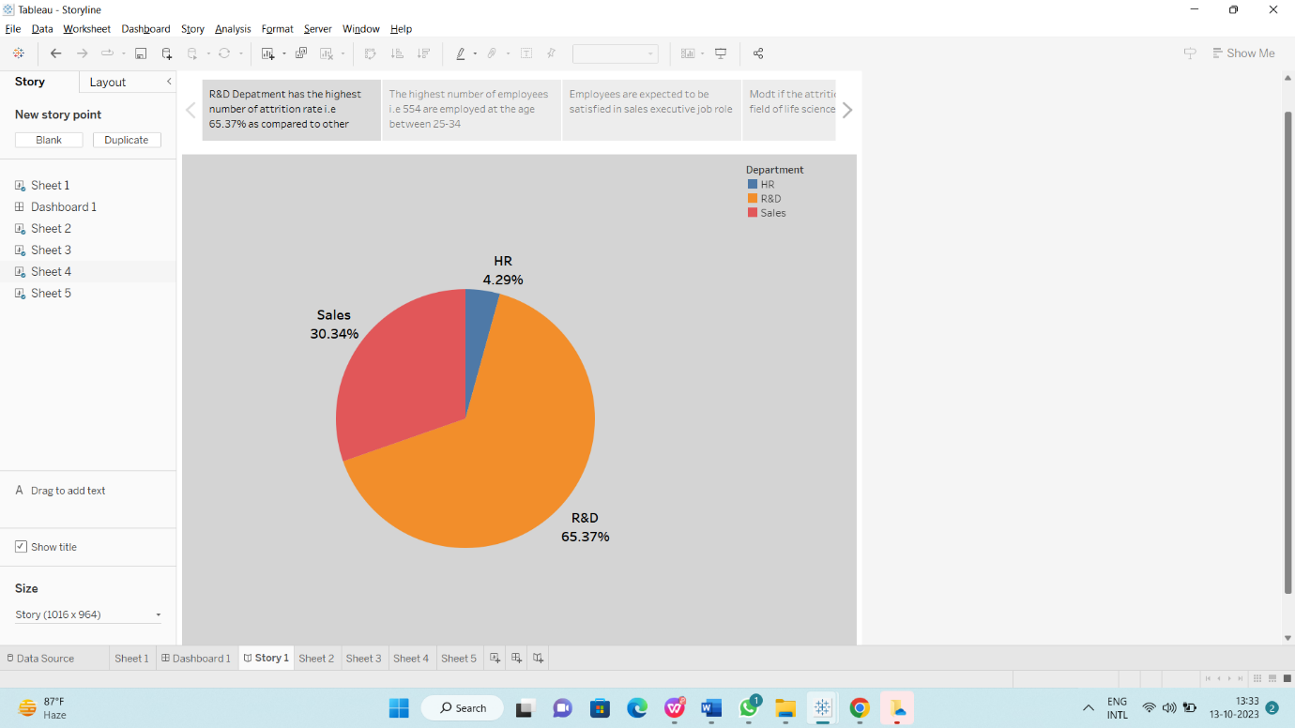

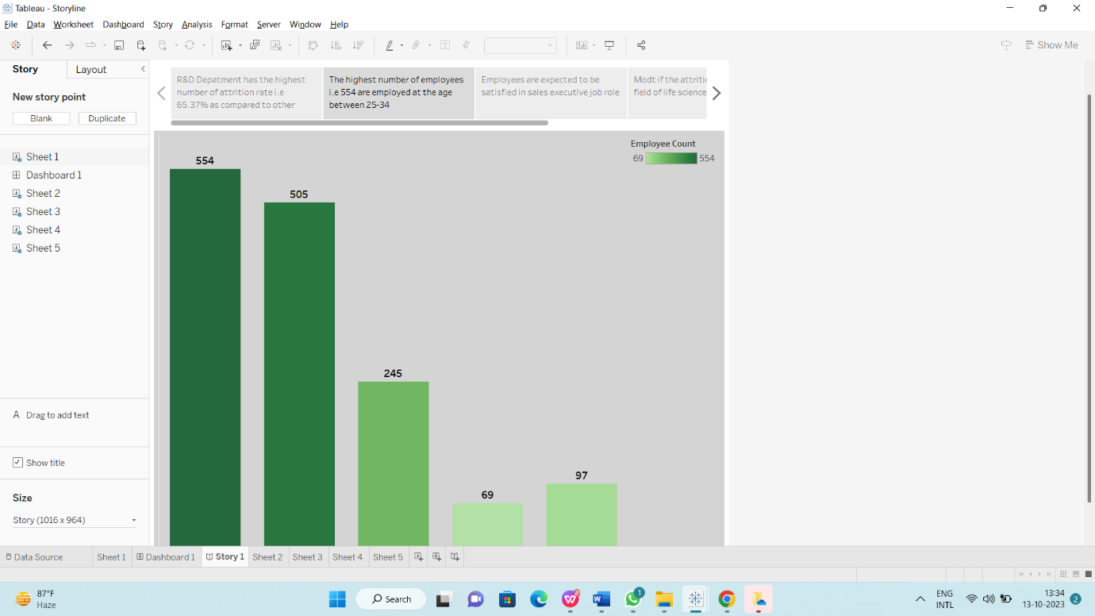

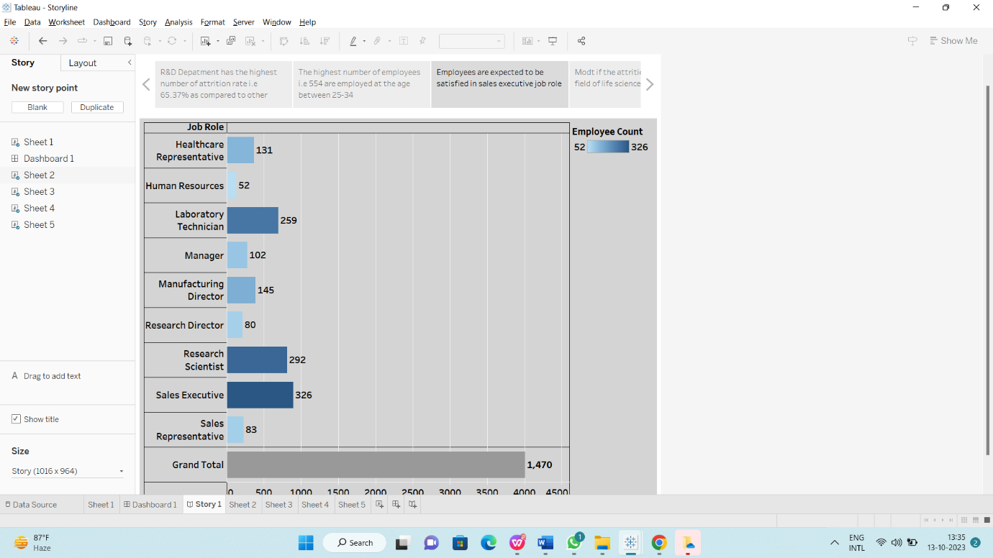

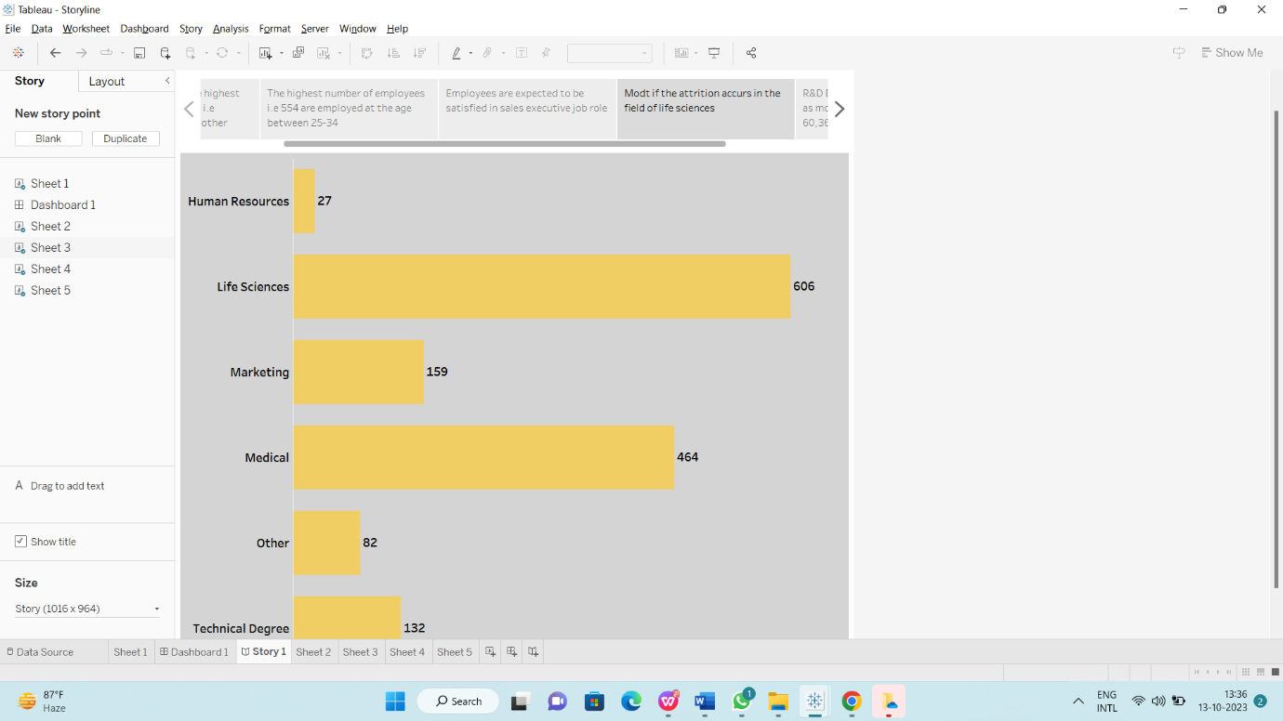

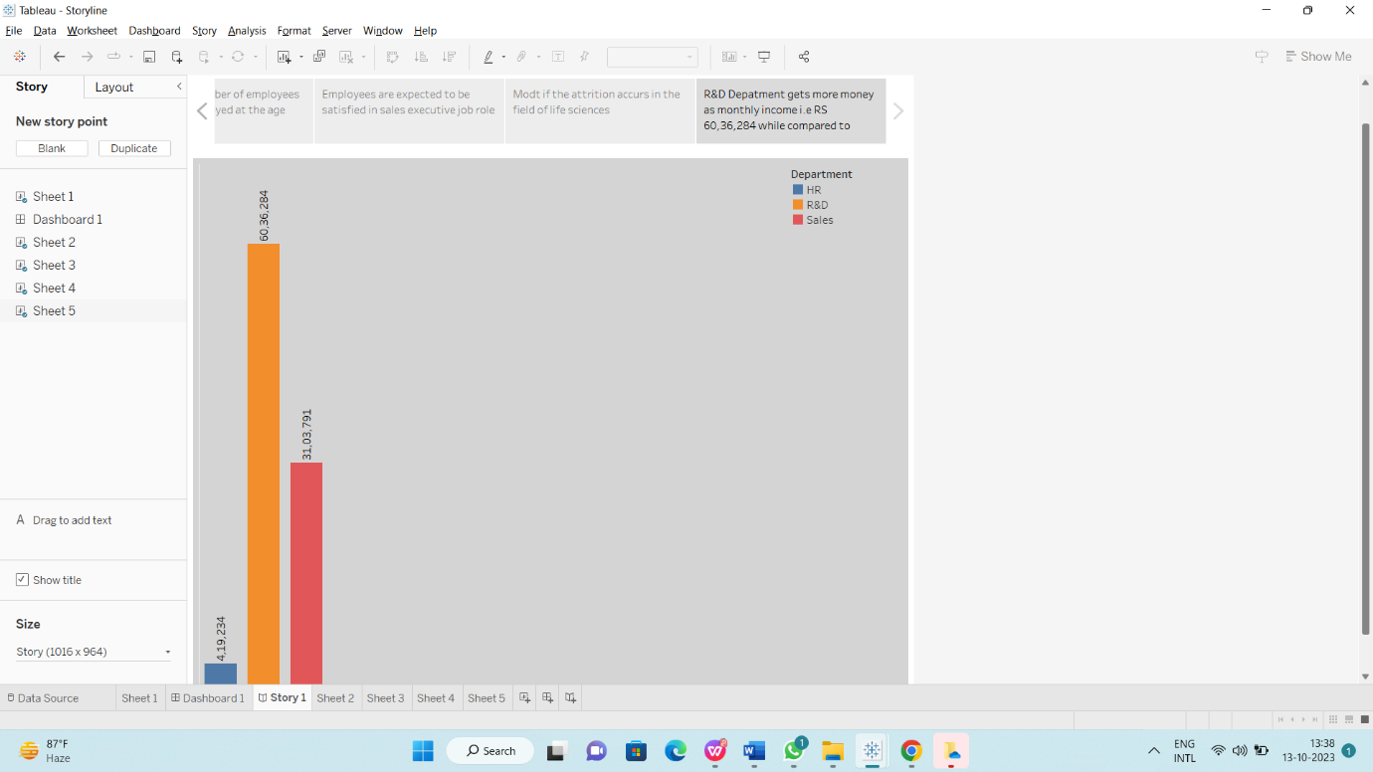

**4. ADVANTAGES & DISADVANTAGES:**

**4.1: ADVANTAGES**

**Talent Acquisition:** HR plays a key role in recruiting and hiring the right talent, which is crucial for the success of an organization**.**

**Employee Development:** HR is responsible for training and development programs that help employees improve their skills and contribute more effectively to the company.

**Compliance and Legal Support:** HR ensures that the company complies with labor laws and regulations, reducing legal risks.

**Conflict Resolution:** HR can mediate disputes and help maintain a harmonious work environment.

**4.2: DISADVANTAGES**

**Administrative Overhead:** HR functions can involve substantial administrative tasks, which can be time-consuming and costly.

**Bureaucracy:** Overly complex HR processes can lead to bureaucracy and slow decision-making.

**Resistance to Change:** HR departments may resist adopting new technologies or modern practices, hindering innovation. Cost: Maintaining an HR department can be expensive, especially for small businesses.

**Cost:** Maintaining an HR department can be expensive, especially for small businesses.

**5. APPLICATIONS:**

**Managerial Effectiveness:** Evaluate the effectiveness of managers by measuring employee satisfaction, performance, and retention rates among their teams.

**Cost of Talent Management:** Calculate and visualize the cost associated with various aspects of talent management, helping HR allocate resources effectively.

**Workforce Planning:** Predict future talent needs by analyzing historical data and visualizing workforce trends to align talent management strategies with organizational goals.

**6. CONCLUSION:**

Hereby We Understand How To Use Tableau Applications And Analyzing The Given Data. Using Tableau Application We Can Create Visualizations For Easy Understandings.

**7. FUTURE SCOPE:**

The future scope of HR scorecards for measuring success in talent management is promising. As organizations continue to recognize the critical role of human capital in their success, HR analytics and scorecards will play a vital role in optimizing talent management. Here are some aspects of their future scope:

**Data-Driven Decision Making:** HR scorecards will enable data-driven decision-making in talent management, helping organizations identify trends, strengths, and weaknesses in their workforce.

**Predictive Analytics:** HR scorecards will increasingly incorporate predictive analytics to anticipate future talent needs, attrition rates, and skill gaps.

**Employee Experience:** Measuring and improving the employee experience will become a key focus, with HR scorecards assessing factors like engagement, well-being, and career development.